**Liber-Primus Hangman demo V0.1**

**Introduction:** This is a working demo, with limited testing. The purpose of this app is to help find possible phrases that could be in the Liber Primus.

**Requires:** python 2 or 3 and PyQT4

Tested on a few linux distros and Windows 7

**Important:** n-gram data files **must** be in this relative path

<install>\ngram_data\4gram\<letters>\file.text

And

<install>\ngram_data\1gram\<letter>\file.text

**It’s way too big:** The way of separating n-gram data into many files makes access fast, but takes up much more space. This can probably be improved. But don’t we all have many spare GB?

**Run:** LP_Hangman.py

**Known Issues:** The Liber Primus sentences structure is basically correct, but without punctuation at the moment. Sentences with less than 4 words will result in undefined behaviour. Yeah ,we know there’s a lot of data ☺

**Hints and Tips: Hopefully you should see something like this:**

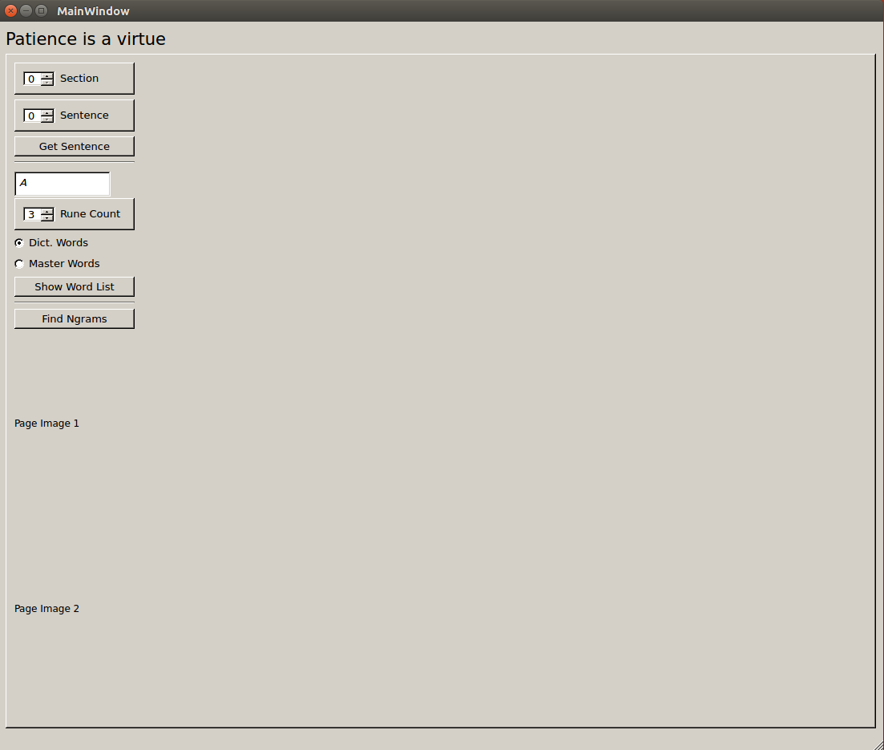

Choose a section (by side images) and sentence (by 4-dots). Press “**Get Sentence**”. This should build the main display with GUI_wordWidget for each word. The displayed image pages from the Liber Primus are not yet correct.

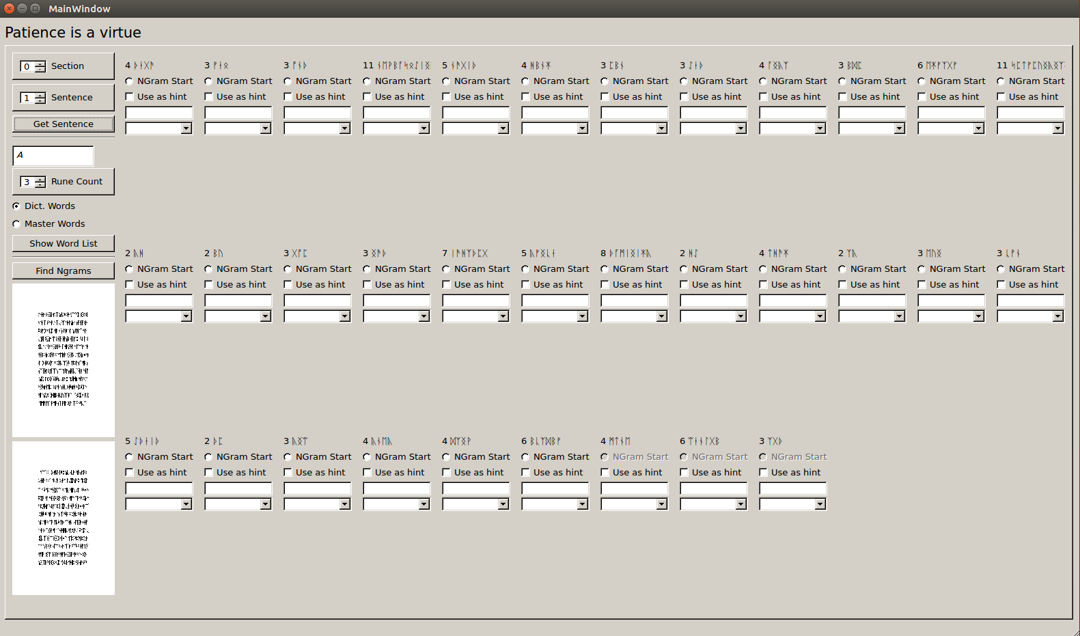

Example GUI_wordWidget

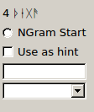

Each GUI_wordWidget has:

***Top label***, with word-rune-count and runes

***Ngram Start*** radio-Button, select to make this word the start of the 4-gram being considered

***Use as hint*** check box, select if you want to use the current Text Entry as a hint when looking up n-grams

***Text Entry***, your chosen word (or first letters of a word)

**Unique Words,** Combo box that is filled with unique words after an N-gram search

**Choose an N-gram**

We work in 4-grams, choose an Ngram start radio button, this will activate the next 3 wordWidget and deactivate the rest. The last 3 n-grams should always be de-activated.

Press “**Find Ngrams**” each unique word will be added to the combo boxes, and a pop-up-window of all the complete n-grams will be displayed.

For quicker results choose the first letter (or first few letters) of the first n-gram, and make sure “**Use as hint**” is checked. “**Use as hint**” for each word in the n-gram can be used to narrow your search.

While searching, the search criteria will be displayed in the Top Left.

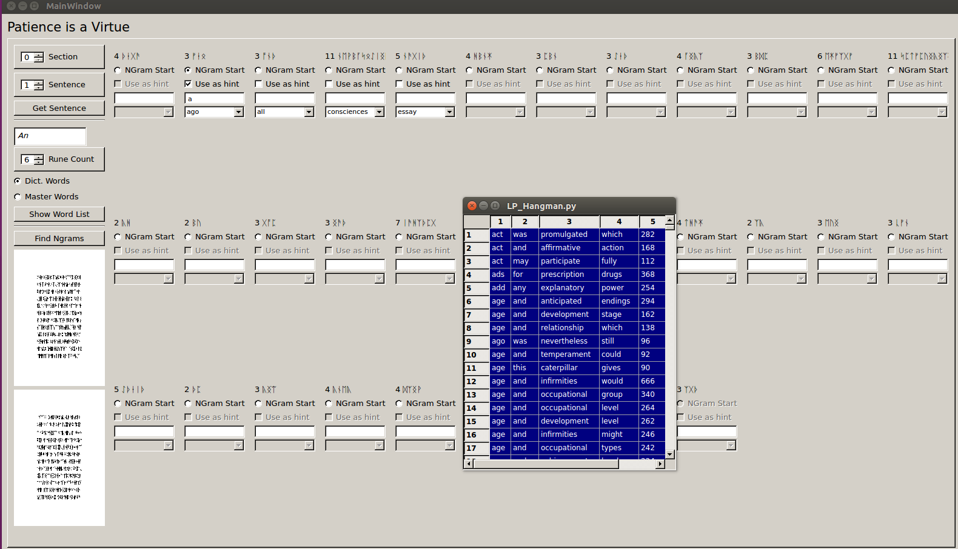

Not sure of what words you can choose? Try the oneGram_Finder, on the Left hand Panel. Choose your starting letters, word-rune-count, and press “*Show Word List*” to display a pop-up window of all matching words, with their count from the corpus.

**oneGram_Finder Controls**

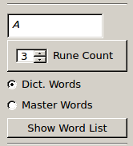

Example 1-grams:

